

**Department of Electrical & Computer Engineering**

**North South University**

**Final Assignment 1**

**Submitted By**

**Name:** Mohammed Mahmudur Rahman

**Student ID:** 1520386043

**Course:** Introduction to Communication (EEE321.L)

**Submitted to**Shajnush Amir

1. **What do you understand by ADC? Mention some applications of ADC**

**Answer:** ADC stands for Analog to Digital Converter. It converts analog signals into digital binary signal. An ADC works by sampling the value of the input at discrete intervals in time. Provided that the input is sampled above the Nyquist rate, defined as twice the highest frequency of interest, then all frequencies in the signal can be reconstructed.

In the real world, every real quantity such as voice, temperature, weight etc exists in the analog state. And it cannot be processed by any digital device such as a computer or a cell phone.

Analog To Digital Conversion Steps are:

1. **Sample:**

The sample block function is to sample the input analog signal at a specific time interval. The samples are taken in continuous amplitude & possess real value but they are discrete with respect to time.

The sampling frequency plays important role in the conversion. So it is maintained at a specific rate. The sampling rate is set according to the requirement of the system.

1. **Hold:**

The second block used in ADC is the ‘Hold’ block. It has no function. It only holds the sample amplitude until the next sample is taken. The hold value remains unchanged till the next sample.

1. **Quantize**

This block is used for quantization. It converts the analog or continuous amplitude into discrete amplitude.

The on hold continuous amplitude value in hold block goes through ‘quantize’ block & becomes discrete in amplitude. The signal is now in digital form as it has discrete time & discrete amplitude.

1. **Encoder**

The encoder block converts the digital signal into binary form i.e. into bits.

As we know that the digital devices operate on binary signals so it is necessary to convert the digital signal into the binary form using the Encoder.

This is the whole process of converting an Analog signal into digital form using an Analog to Digital Converter. This whole conversion occurs in a microsecond.

**Application of ADC**

In the modern world of growing technology, we are dependent on digital devices. These digital devices operate on the digital signal. But not every quantity is in digital form instead they are in analog form. So an ADC is used for converting analog signals into digital signals. The applications of ADC are limitless. Some of these applications given below:

* Cell phones operate on the digital voice signal. Originally the voice is in analog form, which is converted through ADC before feeding to the cell phone transmitter.
* Images and videos captured using camera is stored in any digital device, is also converted into digital form using ADC.
* Medical Imaging like x-ray & MRI also uses ADC to convert images into Digital form before modification. They are then modified for better understanding.
* Music from the cassette is also converted into the digital form such as CDs and thumb drives using ADC converters.
* Digital Oscilloscope also contains ADC for converting Analog signal into a digital signal for display purposes & different other features.
* Air conditioner contains temperature sensors for maintaining the room temperature. This temperature is converted into digital form using ADC so that onboard controller can read & adjust the cooling effect.

In today’s modern world almost every device has become the digital version of itself & they need to have ADC in it. Because it has to operate in digital domain which can be only acquired using analog to digital converter (ADC).

1. **What is ASK, FSK and PSK? What is the difference between ASK, FSK, PSK and  
   AM, FM, PM?**

**Answer: ASK:** Amplitude shift keying(ASK) is a type of amplitude modulation that represents digital data. In this we transmit a carrier wave(RF) of high frequency when the binary digit is 1 and no signal when the binary signal is 0. But for practical purposes a very less amplitude signal is still transmitted for the distinguish for the 1 and 0 transmitted. Here the modulating signal is a digital signal that is varied in accordance with the amplitude of a carrier signal.

**FSK:** Frequency-shift keying is a frequency modulation scheme in which digital information is transmitted through discrete frequency changes of a carrier signal. FSK is the digital modulation technique in which the frequency of the carrier signal varies according to the digital signal changes. ... The output of a FSK modulated wave is high in frequency for a binary High input and is low in frequency for a binary Low input. Frequency-shift keying (FSK) is commonly used over telephone lines for Caller ID (displaying callers' numbers) and remote metering applications. There are several variations of this technology.

**PSK:** Phase-shift keying is a digital modulation process which conveys data by changing the phase of a constant frequency reference signal. The modulation is accomplished by varying the sine and cosine inputs at a precise time. It is widely used for wireless LANs, RFID and Bluetooth communication.

**AM:** In amplitude modulation, the modulating signal is a analog signal which is varied in accordance with amplitude of a carrier signal.

In this the message signal is multiplied with the carrier(RF) of high frequency. By doing this the amplitude of the carrier is changed according to the message signal voltage which is low frequency. So the carrier is being modulated in amplitude by the message signal.

**FM:** Frequency modulation (**FM**) is the encoding of information in a carrier wave by varying the instantaneous frequency of the wave.

In FM, the carrier amplitude remains constant and the carrier frequency is changed by the modulating signal. As the amplitude of the information signal varies, the carrier frequency shifts proportionately. As the modulating signal amplitude increases, the carrier frequency increases.

**PM:** Phase modulation (**PM**) is a modulation pattern for conditioning **communication** signals for transmission. It encodes a message signal as variations in the instantaneous phase of a carrier wave. ... The phase of a carrier signal is modulated to follow the changing signal level (amplitude) of the message signal.

**Differences between ASK, FSK and PSK:**

| **Parameters** | **ASK** | **FSK** | **PSK** |
| --- | --- | --- | --- |
| Variable characteristics | Amplitude | Frequency | Phase |
| Bandwidth | Is proportional to signal rate (B =(1+d)S),d is due to modulation & filtering ,lies between 0 & 1. | B=(1+d)×S+2Δf | B=(1+d)×S |
| Noise immunity | low | High | High |
| Complexity | Simple | Moderately complex | Very complex |
| Error probability | High | Low | Low |
| Performance in presence of noise | Poor | Better than ASK | Better than FSK |
| Bit rate | Suitable upto 100 bits/sec | Suitable upto about 1200 bits/sec | Suitable for high bit rates |

**Difference between AM, FM and PM modulation techniques.**

|  |  |  |  |
| --- | --- | --- | --- |
| **Parameter** | **AM** | **FM** | **PM** |
| Function | amplitude of carrier wave varies as per amplitude or voltage of modulating signal input. | Frequency of carrier wave varies as per voltage of modulating signal input. | Phase of carrier wave varies as per voltage of modulating signal input. |
| Carrier parameter | frequency of carrier wave is kept constant | amplitude of carrier wave is kept constant | amplitude of carrier wave is kept constant |
| Types | AM types include DSB-SC, SSB, VSB etc. Refer [DSB-SC vs SSB-SC](https://www.rfwireless-world.com/Terminology/DSBSC-vs-SSBSC.html) and [SSB vs VSB modulation](https://www.rfwireless-world.com/Terminology/SSB-modulation-vs-VSB-modulation.html) | Digital FM types include FSK, GFSK, Offset FSK etc. Refer [MSK and GMSK modulation](https://www.rfwireless-world.com/Terminology/MSK-GMSK.html) | Digital PM types include BPSK, QPSK, QAM(combination of amplitude and phase modulation types) Refer [BPSK and QPSK](https://www.rfwireless-world.com/Terminology/BPSK-vs-QPSK.html), [QAM](https://www.rfwireless-world.com/Terminology/QAM.html) modulation types. |

**Answer to question no: 03(i)**

MATLAB Code:

%name: Mohammed Mahmudur Rahman

%ID# 1520386043

%Section: 03

clc, clear all;

A= [0 1 1 0 1 0 0 1 1 0]

n= length(A);

t= 0:0.01: n;

message= [];

for i=0: 1: n-1;

message((i*100)+1: 1: ((i+1)*100)+1) =A(i+1);

end

plot(t,message)

grid on;

ylim([ -1.5 1.5]);

legend('Message Signal');

title('Name: Mohammed Mahmudur Rahman, ID# 1520356043. sec# 03');

Graph:

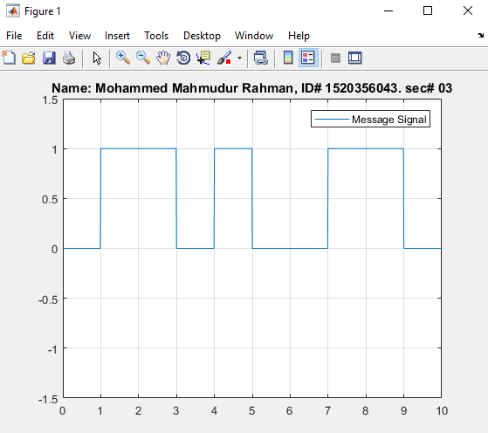

**Answer to question no: 3(ii)**

MATLAB CODE:

%name: Mohammed Mahmudur Rahman

%ID# 1520386043

%Section: 03

clc, clear all;

A= [0 1 1 0 1 0 0 1 1 0] ;

n= length(A);

mt= [];

for i= 0: 1: n-1;

mt((i*100)+1: 1: ((i+1)*100)+1) = A(i+1);

end

t= 0: 0.01 : n;

ct= sin(2*pi*3*t);

ask= mt.*ct

plot(t, ask);

grid on;

ylim([ -1.5 1.5]);

title('Name: Mohammed Mahmudur Rahman, ID# 1520356043. sec# 03');

Graph:

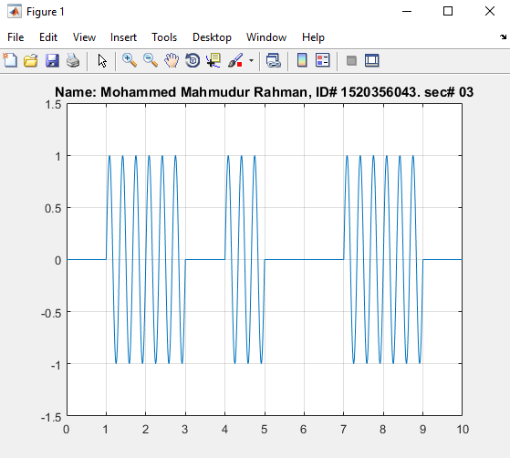

**Answer to question no: 3(iii)**

MATLAB CODE:

%name: Mohammed Mahmudur Rahman

%ID# 1520386043

%Section: 03

clc, clear all;

A= [0 1 1 0 1 0 0 1 1 0];

n= length(A);

mt= [];

for i=0: 1: n-1;

mt((i*100)+1: 1: ((i+1)*100)+1) =A(i+1);

end

t= 0: 0.01: n;

fc =2;

f_dev=4;

ct= sin(2*pi*fc*t);

fsk = sin(2*pi*(fc+f_dev*mt).*t);

plot (t,fsk, 'b');

grid on;

ylim([-1.2 1.2]);

title('Name: Mohammed Mahmudur Rahman, ID# 1520356043. sec# 03');

Graph:

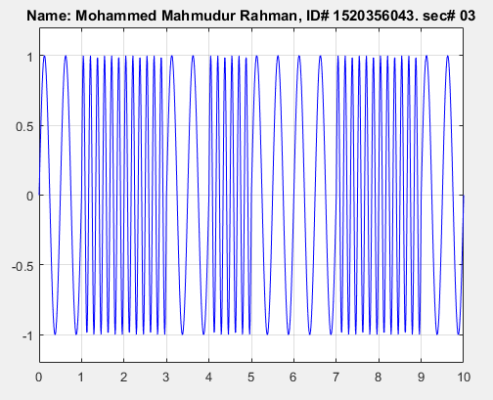

**Answer to question no: 3(iv)**

MATLAB CODE:

%name: Mohammed Mahmudur Rahman

%ID# 1520386043

%Section: 03

clc, clear all;

A= [0 1 1 0 1 0 0 1 1 0];

n= length(A);

mt= [];

for i=0: 1: n-1;

mt((i*100)+1: 1: ((i+1)*100)+1) =A(i+1);

end

t= 0: 0.01 : n;

fc= 3;

ct = sin(2*pi*fc*t);

psk = sin(2*pi*fc*t + pi.*mt);

plot( t, psk);

grid on;

title('Name: Mohammed Mahmudur Rahman, ID# 1520356043. sec# 03');

ylim([ -1.5 1.5]);

Graph:

